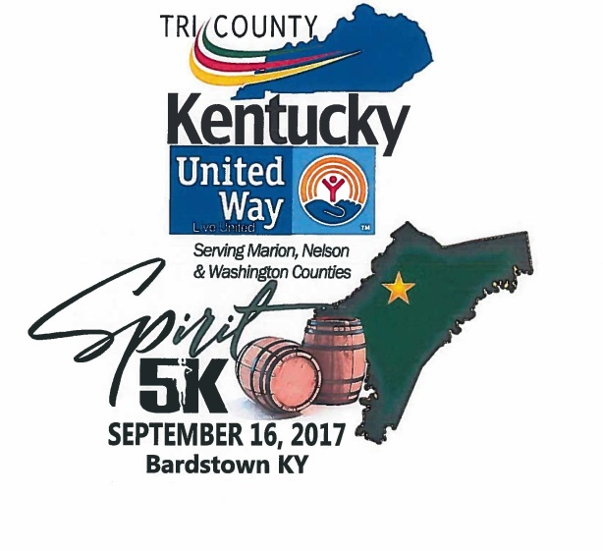
Tri-County Trifecta

1st Spirit 5k

2nd Farmers National Bank Pokey Pig

3rd Sorghum Shuffle

1st Race of the Tri-County Trifecta

ONLINE REGISTRATION:
Registration Fee (due by September 9th) $25 for Adults
Large Groups/Company Groups can contact Dooley Mattingly (502-827-3472)
The Course: Start/finish line will be in front of Civic Center 321 South 3rd Street Bardstown KY 40004.
T-Shirts guaranteed if registered before September 9th
First 250 Registered Age 21+ will receive a goodie bag from Heaven Hill
Race Day: Packet pickup and registration will be from 7:00 -8:00 am in front of the Civic Center in Bardstown. The race will be held rain or shine and begin promptly at 8:30am.
Awards: Awards will be given to the overall male and female winners. A barrel head plaque will be given to the 1st male and female in each age division. 2nd and 3rd in each age division will receive medals. *any winner of an age group under 21 will not receive a barrel head.
Results: Results will be available at www.headfirstperformance.com.
Name:
Address: City: Slate: Zip:
Phone: Email:
Gender: M F (circle one) T-Shirt Size: S M L XL XXL XXXL
Age on race day: Age Divisions: 12 & Under 13-17 18-24 25-29 30-34 35-39
40-44 45-49 50-55 56-60 61+
Waiver of Liability In consideration of the acceptance of my entry, I, intending to be legally bound, do hereby for myself, my heirs, my executors, and administrators, do waive and release forever any and all rights and claims for damages I may accrue against all persons and agencies namely, Tri-County Kentucky United Way and others involved with promoting the race as listing by name, their successors, representatives, and assignees for any and all injuries suffered by me while traveling to and from and while participating in The Spirit 5K on Saturday, September 16th 2017in Bardstown, Kentucky. I attest and verify I have full knowledge of the risk involved in the event and that I am physically fit and sufficiently trained to participate in it.
Signature: Date.
Signature of Parent, if under 18 years of age:
Please send or drop off forms and check to
Tri-County United Way • 321 South 3rd Street • Bardstown, KY 40004 •

